SARDAR VALLABHBHAI NATIONAL INSTITUTE OF TECHNOLOGY, SURAT
DEPARTMENT OF CIVIL ENGINEERING
CONSTRUCTION TECHNOLOGY SECTION
CONSTRUCTION MANAGEMENT LABORATORY (CECT 204)
Construction Management (CM) laboratory was set up in the year 2020 when the new PG program on Construction Technology and Management Section was commenced in AY 2020-21. The laboratory is located at Room No. 002, ground floor of the Advance Research Center (ARC) building (Figure 1). The laboratory facilities are utilized by postgraduate students and research scholars their laboratory and research work. Currently, it is equipped with eight desktops, and 20 more are in the procurement stage. The list of equipment and software available in the laboratory is given below:
Sr. No. | Name of Equipment and Software
Equipment
1 | VR Gaming System (sponsored by ICHR)
Software
1 | Microsoft Project (version 2021)
2 | Primavera Contractor (version 6.1)
3 | Vensim DSS (version 9.1.1)
4 | Microsoft Office (version 2021)
5 | Autodesk Revit Architecture (Student version)

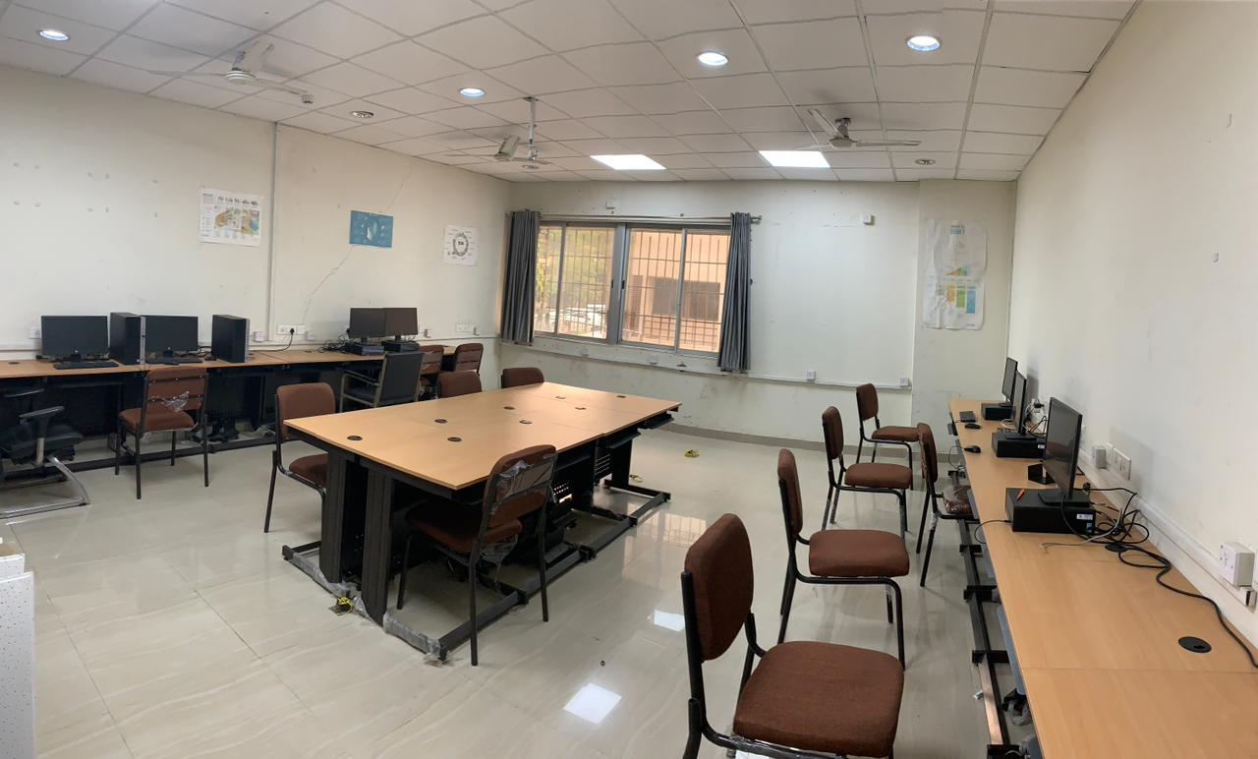
Figure 1: Construction Management Laboratory at 002 GF ARC
Information Regarding VR Gaming Systems
The phrase “virtual reality gaming” refers to a new generation of computer applications that can display a three-dimensional (3D) artificial environment of existing and new construction facilities. The set-up comprises a VR headset and hand controllers. The system has been purchased and utilized to develop a heritage walkthrough and document of English, Dutch, and Armenian cemetery under the joint research project “IT INDIAN HERITAGE PLATFORM: Enhancing cultural resilience in India by applying digital technologies to Indian tangible and intangible heritage” (year 2018-2021). The research was carried out in collaboration between SVNIT, IIT Delhi, and the University of Salford Manchester, sponsored by the Indian Council of Historical Research (ICHR) India and the Arts and Humanities Research Council (AHRC) UK. As shown in Figure 2b, this system is used by one of the research scholars in his Ph.D. work and its thesis titled “Development of Artificial Intelligence-based Automatic Visual Inspection and Maintenance Management System for Build Environment” published in September 2022.
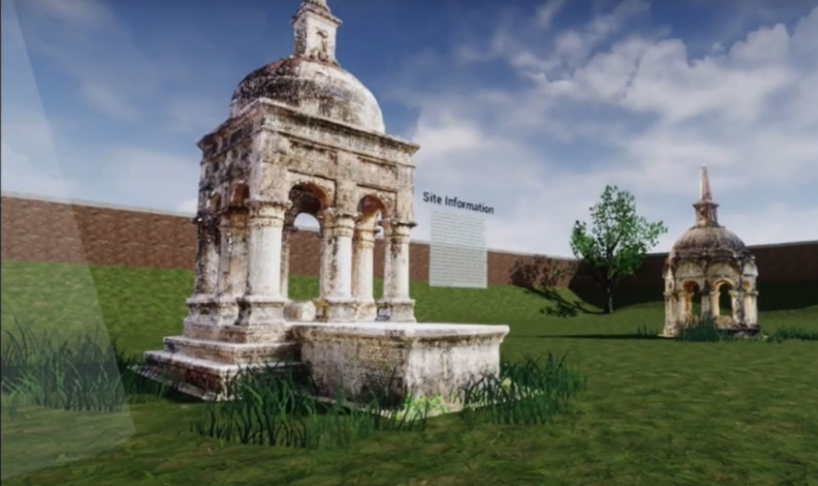 | 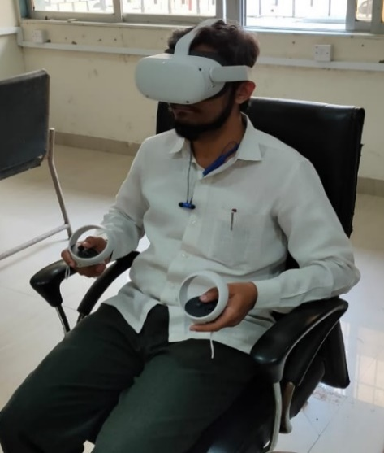
(a) | (b)
Figure 2 (a) VR model; (b) Set-ups of VR gaming system
Information Regarding Vensim DSS software
Vensim is a simulation software that enables dynamic simulation with some discrete event and agent-based modeling to reflect real-world systems. It is a general-purpose software widely used to deal with various problems in the civil engineering domain, such as transportation, project management, environment, and urbanization. A screenshot of its user interface is shown in Figure 3. Vensim DSS software was purchased in the year 2022 from Ventana Systems, Inc. (USA) to develop the fuzzy system dynamics to forecast bridge resilience to conduct feasibility study of paver block manufactured from construction and demolition waste using system dynamic approach.
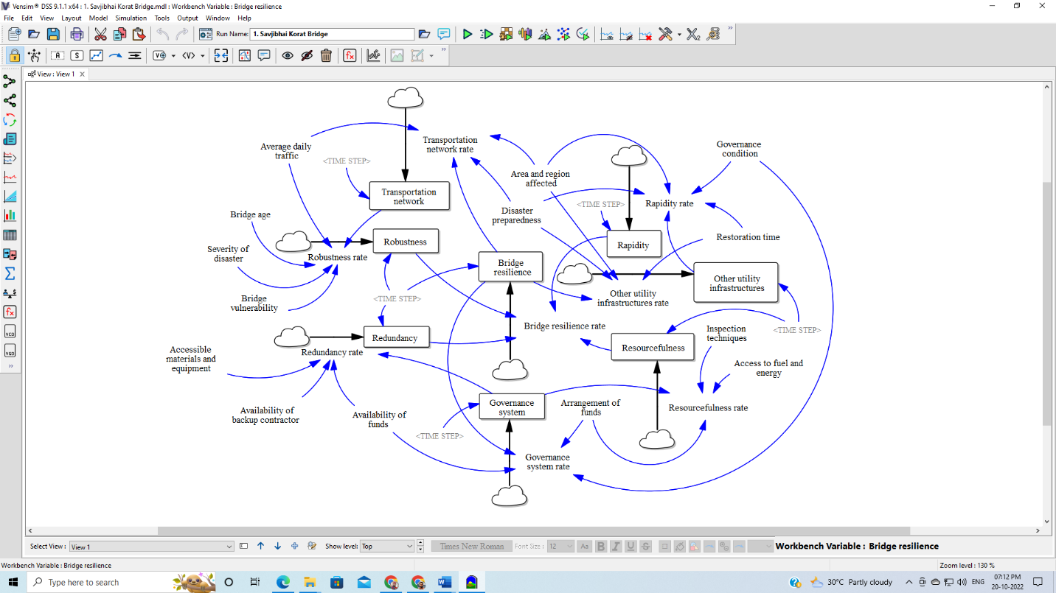
Figure 3. Screenshot of Vensim user interface
LIST OF EXPERIMENTS
Construction Management Laboratory (CECT204) (M. Tech-I (CTM), Semester II)
Sr. No. | Title of Experiment | Hours
1 | Introduction to Primavera, MS Project, and BIM | 02
2 | Creating an enterprise, organization, and project | 04
3 | Developing a calendar | 04
4 | Formulating work breakdown structure and activities with their relationships | 05
5 | Creating schedule for the project and identifying constraints | 04
6 | Assigning roles and resources | 04
7 | Resource analysis and leveling | 04
8 | Creating and writing documents, notebooks, and feedback | 04
9 | Defining baseline and updating project progress | 04
10 | Tracing project progress | 04
11 | Dealing with issues and thresholds | 04
12 | Printing, importing, and exporting data | 02

